JavaScript: Synchronous vs Asynchronous Execution

1. Synchronous Execution
Description: Synchronous execution means code runs line by line. Each task waits until the previous task is completed.
Example:
// Show synchronous vs asynchronous execution.
// synchronous
console.log('Show synchronous vs asynchronous execution.');
console.log("this is example of synchronous")
console.log("match start");
console.log("match break");
console.log("match end");
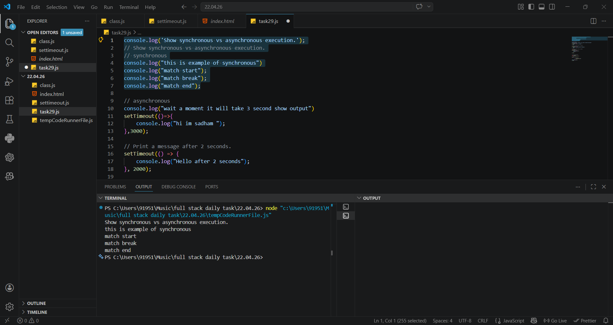
OUTPUT:

2. Asynchronous Execution
Description: Asynchronous execution allows tasks to run later without blocking the main program flow. Functions like setTimeout are used.
Example:
// asynchronous
console.log("wait a moment it will take 3 second show output")
setTimeout(()=>{
console.log("hi im sadham ");
},3000);
OUTPUT:
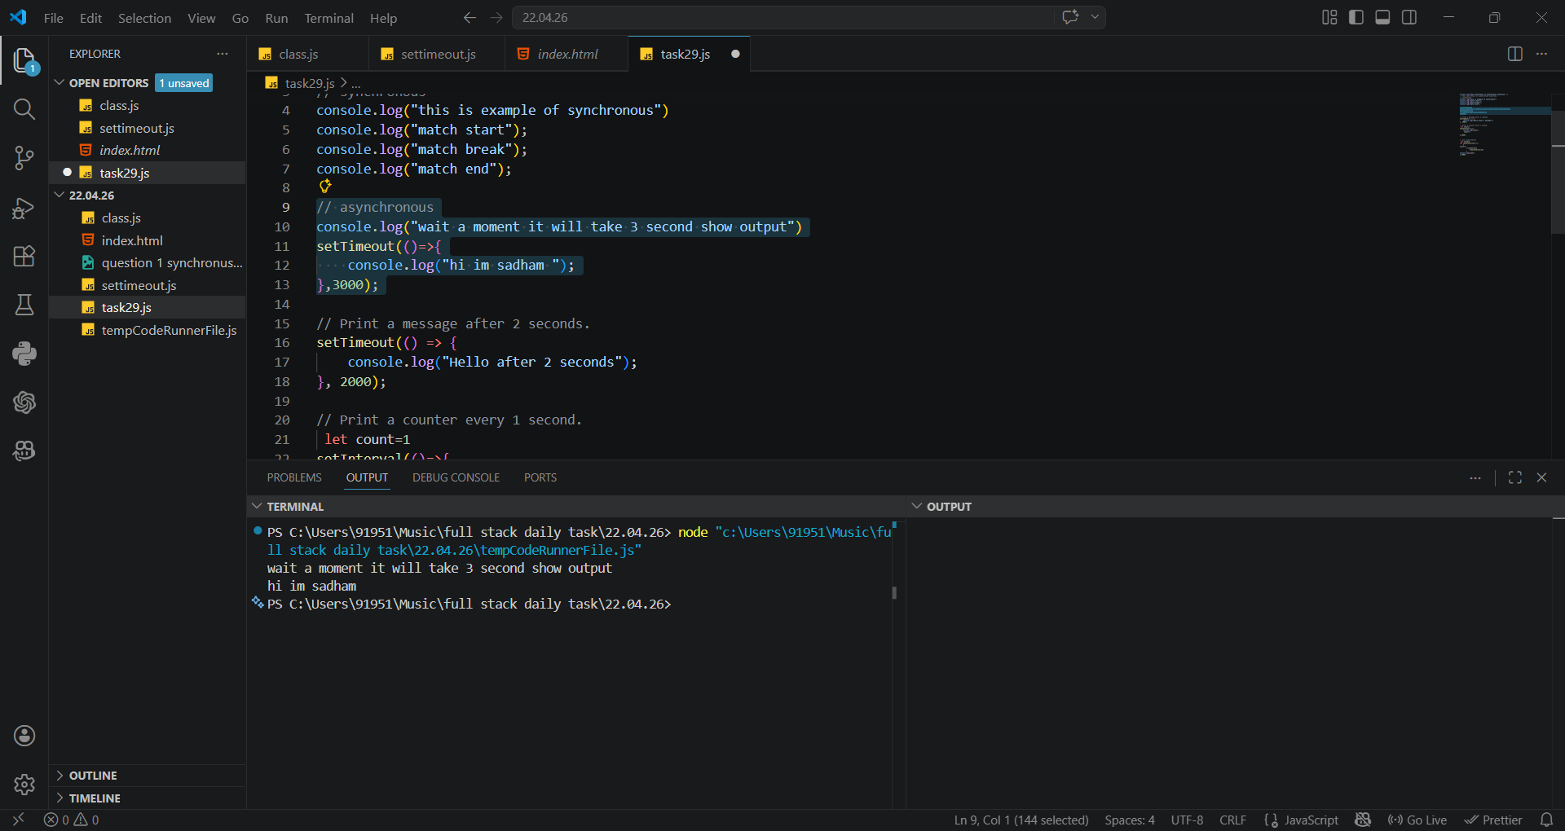
3. Print Message After 2 Seconds
Description: The setTimeout function delays execution of code by a specified time in milliseconds.

Example:
// Print a message after 2 seconds.
setTimeout(() => {
console.log("Hello after 2 seconds");
}, 2000);
OUTPUT:
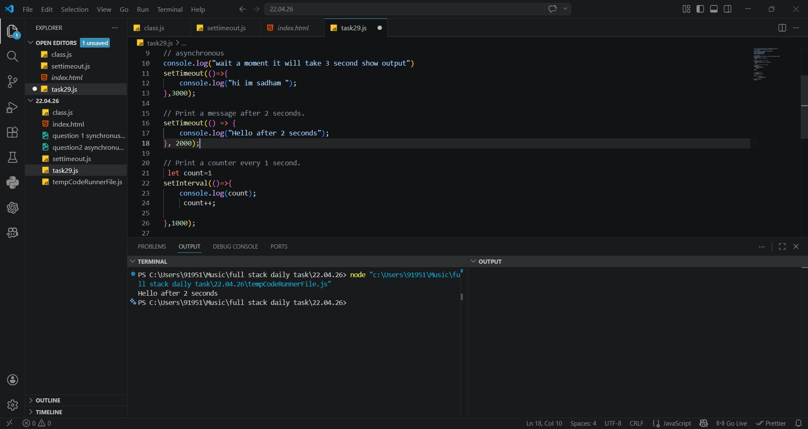

4. Print Counter Every 1 Second
Description: The setInterval function repeatedly executes code at a fixed time interval.
Example:
// Print a counter every 1 second.
let count=1
setInterval(()=>{
console.log(count);
count++;
},1000);
// use clearinterval
let count=0
let id=setInterval(()=>
{
count++;
if(count>10){
clearInterval(id)
}
console.log(count)
},1000);
OUTPUT:
